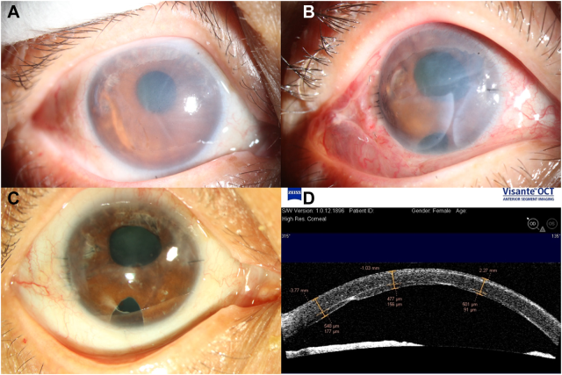

A 52-year-old woman(A) with a diffuse stromal edema, extended peripheralanterior synechiae, and superior iris atrophy. The remaining peripheral tissues derived from 3 donors after standard keratoplasty weretrimmed to a piece of graft and used for endothelial keratoplasty. Six days after surgery (B), the trimmed graft was well adhered to theposterior surface of the recipient’s cornea with gaps among the pieces. C, Completely resolved corneal clarity (corrected distance visualacuity was 20/50) was observed, and (D) 9 months after surgery, anterior segment-OCT imaging showed that the gaps among the piecesdisappeared. Based on the provided images and clinical description please make an ophthalmic diagnosis for this patient. And output the diagnostic conclusions only.

**Iridocorneal Endothelial (ICE) Syndrome (leading to corneal endothelial decompensation with diffuse stromal edema, extended peripheral anterior synechiae, and superior iris atrophy).**